# [Git异常：fatal: could not create work tree dir 'XXX': No such file or directory](http://www.cnblogs.com/dunitian/p/5035595.html)

**GitHub实战系列汇总：**<http://www.cnblogs.com/dunitian/p/5038719.html>

**——————————————————————————————————————————————————————**

**很多人问，明明有git gui 和 github可以直接图形化操作的吗？全部指令干啥？？？**

**呃(⊙o⊙)…呃(⊙o⊙)… ===> 装逼~**

**O(∩_∩)O~，开玩笑的，其实就是为了通用和熟悉git，linux里面照样这样用，多熟悉点基础指令很有用的，**

**如果觉得顿时不开心了、无爱了==>推荐你快速入门：**http://www.imooc.com/learn/390

**———————————————————————————————————————————————————————**

DNT@DESKTOP-PTACRF6 MINGW64 ~/Windows10 (master)  
$ git clone git@github.com:dunitian/IPToPosition.git  
fatal: could not create work tree dir 'IPToPosition': No such file or directory

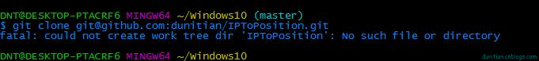

这个看一下执行目录的路径==>~/Windows10 (master)

切换到根目录：cd ~

再输入指令就ok了

DNT@DESKTOP-PTACRF6 MINGW64 ~  
$ git clone git@github.com:dunitian/IPToPosition.git  
Cloning into 'IPToPosition'...  
Warning: Permanently added the RSA host key for IP address '192.30.252.130' to the list of known hosts.  
warning: You appear to have cloned an empty repository.  
Checking connectivity... done.

